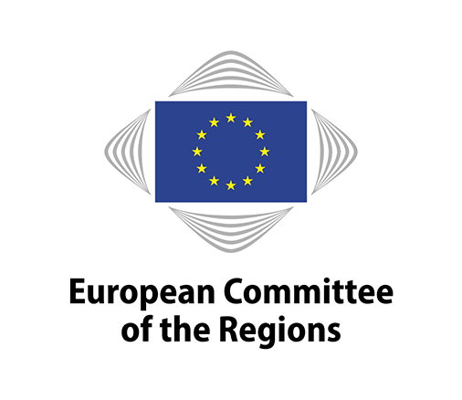
EN

Brussels, 5 October 2017

125th PLENARY SESSION OF THE EUROPEAN COMMITTEE OF THE REGIONS

DRAFT AGENDA

MONDAY 9 OCTOBER 2017
FROM 2.30 P.M. TO 4.30 P.M.

European Parliament
Paul Henri Spaak building – Hemicycle
60 rue Wiertz, B-1047 Brussels

*****************************************

TUESDAY 10 OCTOBER 2017
FROM 3 P.M. TO 9 P.M.
AND
WEDNESDAY 11 OCTOBER 2017
FROM 9 A.M. TO 1 P.M.

Charlemagne Building (European Commission)
Rue de la Loi - 1000 Brussels

*****************************************

Monday 9 October

2.30 p.m. OPENING OF THE SESSION

Adoption of the agenda (COR-2017-03634-00-03-CONVPOJ-TRA)

Official Opening Session of the 15th European Week of Regions and Cities
"Regions and Cities working for a better future"

2.30 - 3.15 p.m. Opening statements

3.15 - 4.30 p.m. Debate with members of the European Committee of the Regions

4.30 p.m. ADJOURNMENT
Tuesday 10 October

3 p.m. OPENING OF THE SESSION

Approval of the minutes of the 124th plenary session, held on 12 and 13 July 2017
(COR-2017-02425-00-00-PV-TRA, COR-2017-02425-00-00-PV-REF, COR-2017-02425-01-00-PV-REF, COR-2017-02425-02-00-PV-REF and COR-2017-02425-03-00-PV-REF)

State of the Union: the view of Regions and Cities

Address by the President of the European Committee of the Regions

Statement by Donald Tusk, President of the European Council
Debate with members

4.30 p.m.

Future of Connecting Europe Facility - Transport
Own-initiative opinion
COR-2017-01531-00-01-PAC-TRA - COTER-VI/027
Rapporteur: Ximo Puig i Ferrer (ES/PES)

5 p.m.

Statement by Miguel Arias Cañete, Commissioner for Climate Action & Energy
Debate with members

Environmental Implementation Review
COR-2017-00836-00-00-PAC-TRA - ENVE-VI/021
COM(2016) 316 final
Rapporteur: Andrew Varah Cooper (UK/EA)

Climate finance: an essential tool for the implementation of the Paris Agreement
Own-initiative opinion
COR-2017-02108-00-00-PAC-TRA - ENVE-VI/024
Rapporteur: Marco Dus (IT/PES)

A European strategy on Cooperative Intelligent Transport Systems
COR-2017-02552-00-00-PAC-TRA - COTER-VI/028
COM(2016) 766 final
Rapporteur: Bouke Arends (NL/PES)
Statement by István Ujhelyi (HU/S&D), Rapporteur of the TRAN Committee of the European Parliament

Strengthening territorial resilience: empowering regions and cities to face globalisation
COR-2017-03202-00-02-PAC-TRA - ECON-VI/024
COM(2017) 0240 final
Rapporteur-General: Micaela Fanelli (IT/PES)

A Strategic Approach to Resilience in the EU's external action
Own initiative opinion
COR-2017-03666-00-01-PAC-TRA - CIVEX-VI/027
JOIN(2017) 0021
Rapporteur-General: Marcin Ociepa (PL/ECR)

9 p.m. ADJOURNMENT

Wednesday 11 October

9 a.m. OPENING OF THE SESSION

Building a European Data Economy
COR-2017-00853-00-01-PAC-TRA - SEDEC-VI/025
COM(2017) 9 final
Rapporteur: Kieran McCarthy (IE/EA)

The European Pillar of Social Rights and Reflection paper on the social dimension of Europe
COR-2017-03141-00-00-PAC-TRA - SEDEC-VI/027
Rapporteur-General: Mauro D'Attis (IT/EPP)
Statement by Maria João Rodrigues (PT/S&D), Member of the European Parliament

A European policy on the seismic requalification of buildings and infrastructure
Own-initiative opinion
COR-2017-01036-00-00-PAC-TRA - NAT-VI/020
Rapporteur: Vito Santarsiero (IT/PES)

Space Strategy for Europe
COR-2016-06726-00-00-PAC-TRA - ENVE-VI/022
COM(2016) 705 final
Rapporteur: Andres Jaadla (EE/ALDE)
Statement by Monika Hohlmeier (DE/EPP), Member of the European Parliament

Reform of EU own resources within the next MFF post-2020
Own-initiative opinion
COR-2017-01530-00-00-PAC-TRA - COTER-VI/026
Rapporteur: Isabelle Boudineau (FR/PES)
Statement by Ivailo Kalfin, special adviser to the European Commission on relations with the European and National Parliaments, and budget revenue

The protection of children in migration
Own-initiative opinion
COR-2017-02782-00-01-PAC-TRA - CIVEX-VI/025
COM(2017) 211 final
Rapporteur: Yoomi Renström (SV/PES)

The services package: A services economy that works for Europeans
Own-initiative opinion
COR-2017-01195-00-01-PAC-TRA - ECON-VI/022
COM(2016) 824 final
COM(2016) 823 final
COM(2016) 822 final
COM(2016) 821 final
COM(2016) 820 final
COM(2016) 822 final/2
Rapporteur: Jean-Luc Vanraes (BE/ALDE)

Resolution on the 2017 European Semester and in view of the 2018 Annual Growth Survey
RESOL-VI/025
COR-2017-03728-00-02-PRES-TRA

Resolution on recommendations to the Heads of State or Government gathering in Brussels on 24 November 2017 for the fifth Eastern Partnership Summit
RESOL-VI/026
COR-2017-04391-00-01-PRES-TRA

New CoR members and alternates (COR-2017-03634-00-00-PSP-TRA) (for information)

Election of Bureau members (COR-2017-03634-00-00-PSP-REF) (for decision)

Any other business

Date of the next meeting

1 p.m. END OF THE PLENARY SESSION

This document has been drawn up in accordance with Rule 15(3) of the Rules of Procedure and can be retrieved at: http://memportal.cor.europa.eu/Meeting/CommitteeAgenda.

_____________

Simplified procedure.
Simplified procedure.
Simplified procedure.
Resolution submitted in accordance with Rule 45.3 a) of the Rules of Procedure.
Urgent Resolution submitted in accordance with Art. 45.3 b) of the Rules of Procedure. It will be removed from the Agenda if not approved by the Bureau on 9 October 2017.

